
Data sheet (lab 1)

Course: CSE209 Electrical Circuits
Title: Introduction to Circuit Elements and Variables

Submitted By:
D.M. Rafiun -Bin- Masud
ID: 2019-3-60-137
Department of CSE

Submitted to:
M Saddam Hossain Khan
Senior Lecturer,
Department of Computer Science and Engineering

Pre Lab:
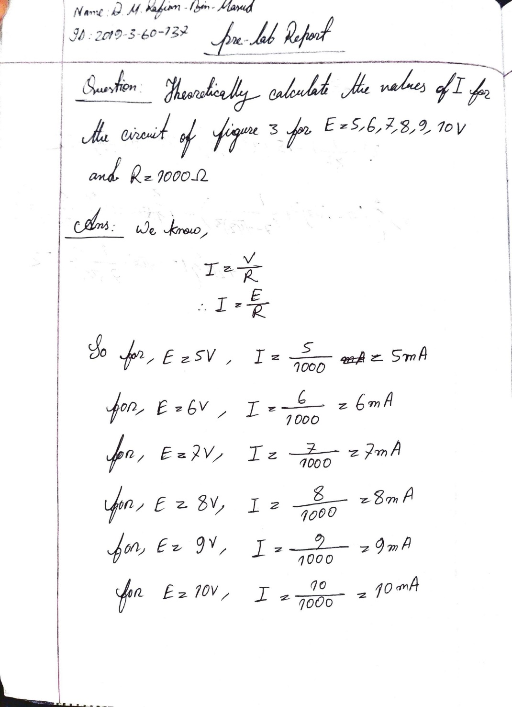

Circuit diagram using PSpice simulator

For 5V,
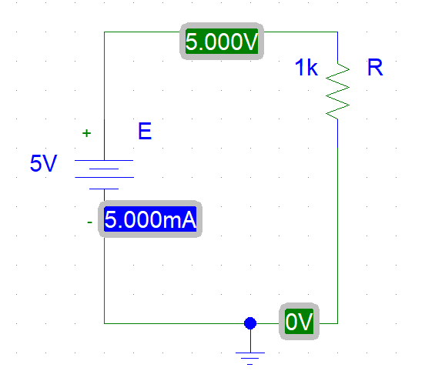
For 6V,
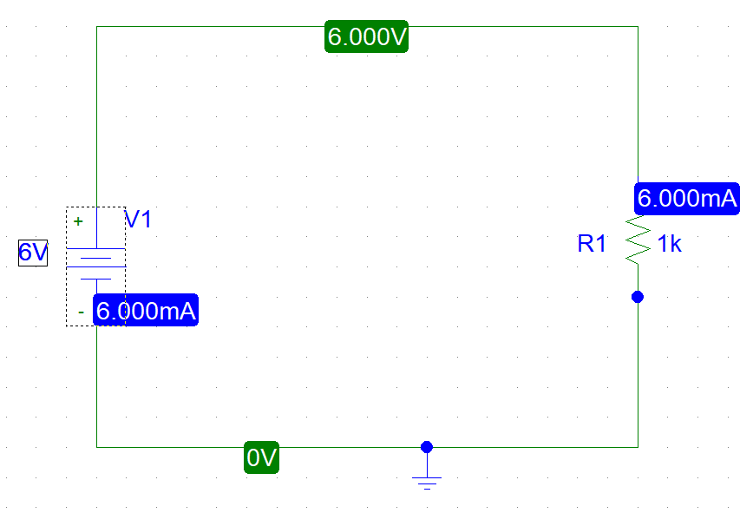

For 7V,
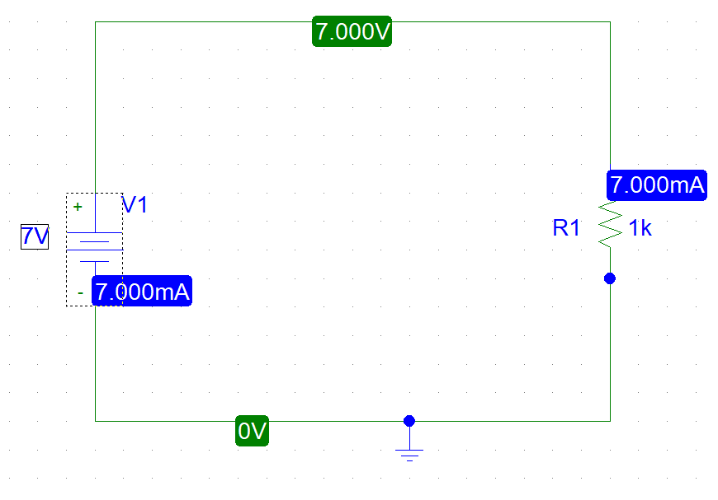

For 8V,
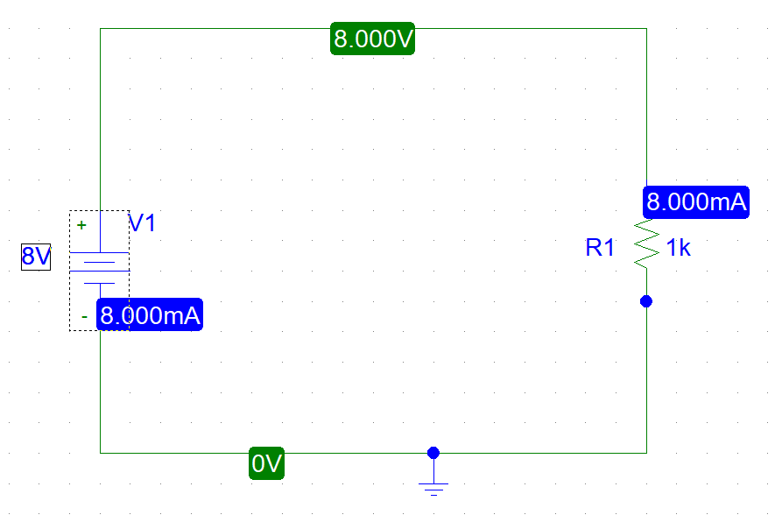

For 9V,

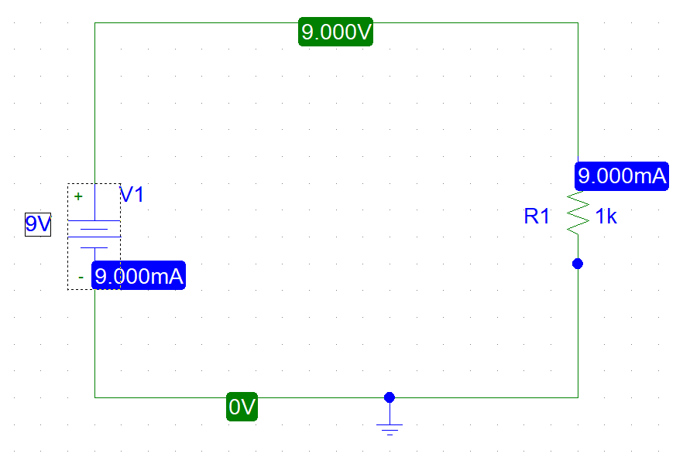
For 10V,
